Academy of Aphasia 57th Annual Meeting
27-29 October, 2019
University of Hong Kong, Hong Kong, SAR
The 57th Annual Meeting of the Academy of Aphasia will be held at the University of Hong Kong, Hong Kong, SAR. The Academy of Aphasia welcomes submissions of original experimental, clinical, theoretical, and historical research from any field that contributes to the study of aphasia, including Speech-Language Pathology, Psychology, Neurology, Neuroscience, Linguistics, History, and Computational Modeling.
Our keynote speaker is Dr. Lyndsey Nickels of Macquarie University. Dr. Nickels is Professor of Cognitive Science, member of the ARC Centre of Excellence in Cognition and its Disorders (CCD), and Macquarie University’s Director of the international Ph.D. program International Doctorate for Experimental Approaches to Language and Brain. She is an internationally-recognized researcher in the cognitive neuropsychology of language, who has carried out landmark work in the neural and cognitive bases of word production and word-production impairments in aphasia. A trained speech-language therapist, Dr. Nickels has made equally important contributions to the aphasia treatment literature, and she has a long-standing commitment to research focused on remediation of language disorders.
Now in its second year, the NIDCD-funded Academy of Aphasia conference grant (R13 DC017375-01) will sponsor student fellows and a of state-of-the-art New Frontiers in Aphasia Research seminar. This year’s speaker for the New Frontiers in Aphasia Research seminar is Dr. Alex Fornito of Monash University. Dr. Fornito is Professor of Psychology at Monash University and directs the Brain and Mental Health Lab. His work uses multidisciplinary methods to examine the brain bases of behaviour, including graph-theoretic analyses of both functional and diffusion MRI data. Accepted student fellows will have the opportunity for focused mentoring and training, and both U.S. and international students are eligible to apply. Further information, including application forms, is available here.
Submission types and details

Presentation types. The annual meeting includes both platform and poster sessions.
Platform sessions include:
- Scientific papers—consisting of original research that has not yet been published.
- Symposia—consisting of a number of papers focusing on a common theme from researchers representing different laboratories. These papers may report on previously published research.
- Mini-Workshops—methodologically oriented sessions consisting of a number of papers reporting a unique approach to a timely topic. The authors of these papers may be from a single research group.
Poster sessions include:
- Scientific papers that can be presented primarily in a visual format.
The Academy considers poster sessions to be as scientifically meritorious as platform sessions. Poster sessions will not conflict with platform sessions.
Guidelines for abstract content. The submitted abstract should provide a concise statement of the problem or hypothesis, procedures and analyses conducted, results obtained, and final conclusion(s) drawn. Abstracts may include a maximum of 500 words (excluding references) as well as one camera-ready figure and one table. See Submissions Procedures below for further details.
Symposia and Mini-Workshops. In the case of symposia and mini-workshops, the organizer should submit an abstract summarizing the topic, including the names and affiliations of all the participants, and the titles of the other abstracts. In addition, an abstract should be submitted for each of the individual presentations. Abstracts for those individual presentations will need to indicate the symposium they are affiliated with as part of the submissions process, in the Acknowledgments (see Submission Procedures below for details). To help in the planning of the program, it is recommended that organizers of symposia and mini-workshops contact the chair of the Program Committee by e-mail (mdickey@pitt.edu) about their plans, and to receive feedback on organizational issues.
Authorship of submissions. More than one abstract may be submitted by an individual, but an individual can be listed as first author on only one submission. Both members and non-members of the Academy are encouraged to submit proposals for scientific papers, symposia and mini-workshops. Student papers must be co-authored by a member of the Academy. All submissions will be given equal consideration on the basis of their scientific merit and fitness for the Academy.
Conference participation. The meeting is open to anyone interested in attending. However, meeting space is limited, and Academy of Aphasia members, authors of accepted papers, and the first authors of rejected papers will have preference if space limitations restrict the number of registrants.

Submission procedures. As in previous years, submission and publication of Academy of Aphasia will be via Frontiers in Human Neuroscience. Proposals must be submitted on-line at:
https://www.frontiersin.org/events/Academy_of_Aphasia_57th_Annual_Meeting/6954

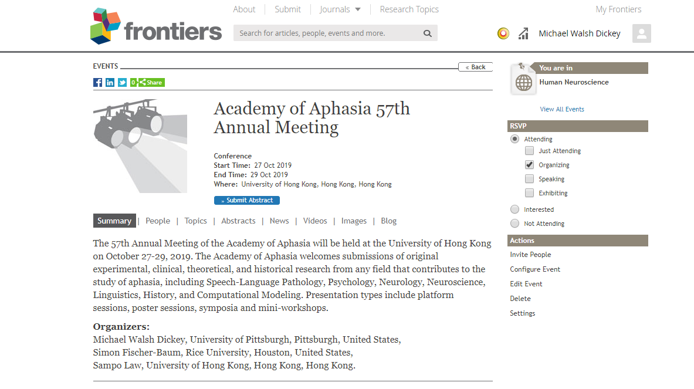
https://www.frontiersin.org/events/Academy_of_Aphasia_57th_Annual_Meeting/6954
From the landing page, click on the blue ‘Submit Abstract’ box (circled in the screen capture above) in order to submit an abstract. NOTE: You must log into your Frontiers account to submit an abstract. If you do not have an account, you must create one prior to submitting.

Abstracts may contain up to 500 words (excluding references), one figure, and one table, and must be in APA 6th edition format. Supplementary materials are not allowed. Abstracts not adhering to these guidelines will be rejected.

Please follow the steps below to submit an abstract:

Page 1:

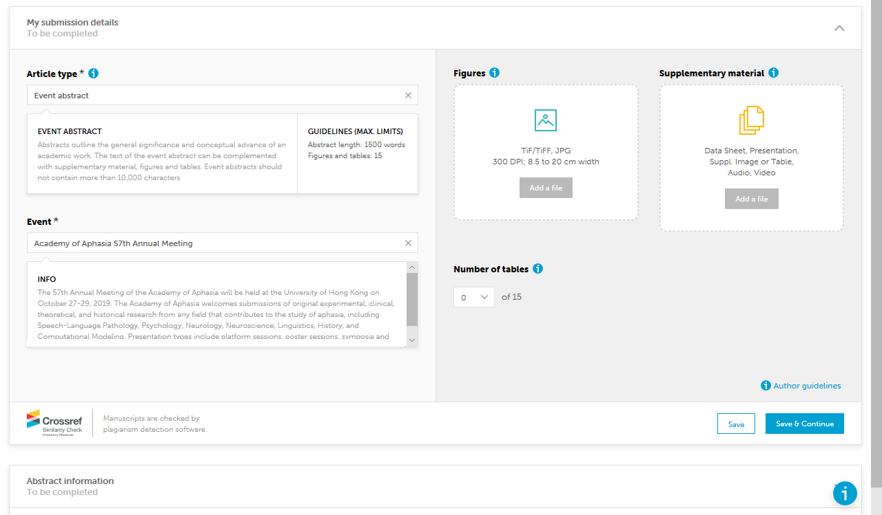
Article type: Select ‘Event Abstract’ (NOTE: this is the default)

Event: Select ‘AoA 57th Annual Meeting’ (NOTE: this is the default)

Figures: Upload up ONE figure here (300 dpi, 8.5-20cm in width; TiFF or JPG format). Figures should be designed to be easily interpretable in B&W.

Tables: Upload up ONE table here.

Supplementary materials are NOT ALLOWED.

Page 2:

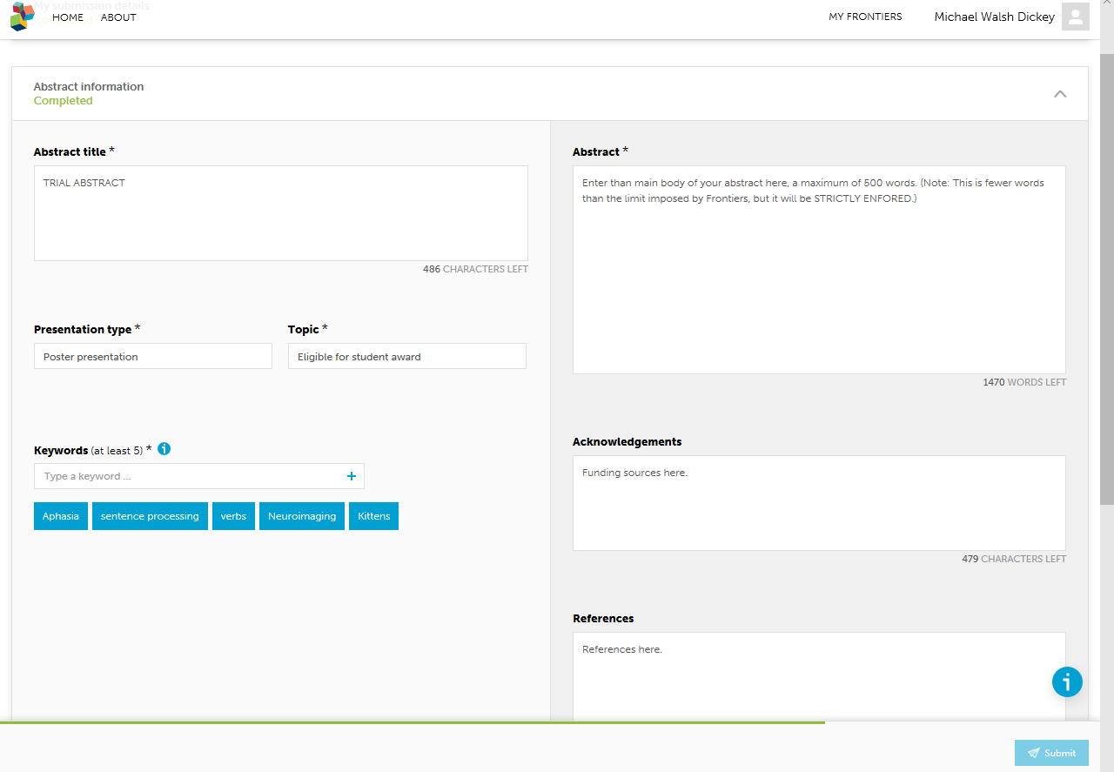
Abstract title: No more than 500 characters.

Presentation type: Select ‘Platform presentation’, ‘symposium presentation’ (if this is the cover abstract for or an individual presentation in a symposium or mini-workshop), or ‘Poster presentation.’ If the submission is part of a symposium or workshop submission, please provide the name of this symposium or workshop in the text box marked Acknowledgements.

Key words. Enter at least 5 key words. Please be specific.
Topic: Select whether the proposal is eligible for the student award. Only proposals with students as first authors are eligible.
Abstract: Enter than main body of your abstract here, a maximum of 500 words. (Note: This is fewer words than the limit imposed by Frontiers, but it will be STRICTLY ENFORED.) Note that you will not be allowed to enter formatting for text (underlining, bolding, etc.). For phonetic symbols, please use the SAMPA conventions (http://www.phon.ucl.ac.uk/home/sampa/).

Acknowledgments: Indicate funding sources here. Also, make sure to provide the name of the symposium if this abstract is associated with a symposium or mini-workshop.
References: Add references here (again, formatting is not allowed).

Page 3:

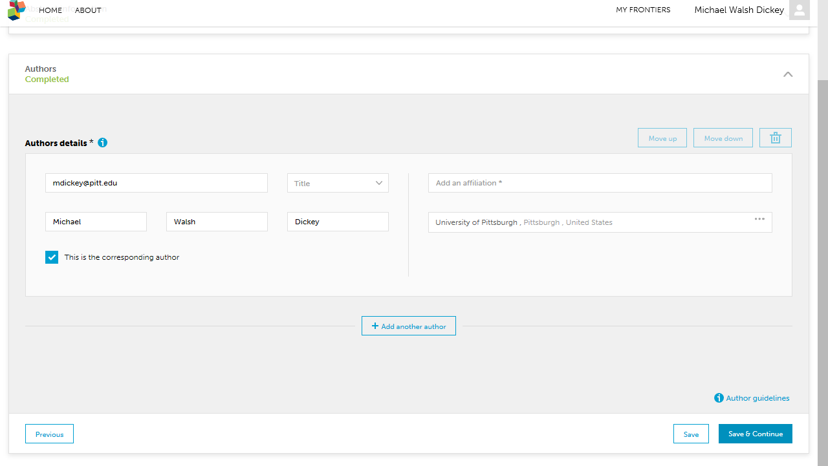

Author details: Enter the authors, designating one person as the corresponding author. If the authors are already registered in Frontiers, the fields (e.g., name, affiliation) will automatically populate.

Page 4:
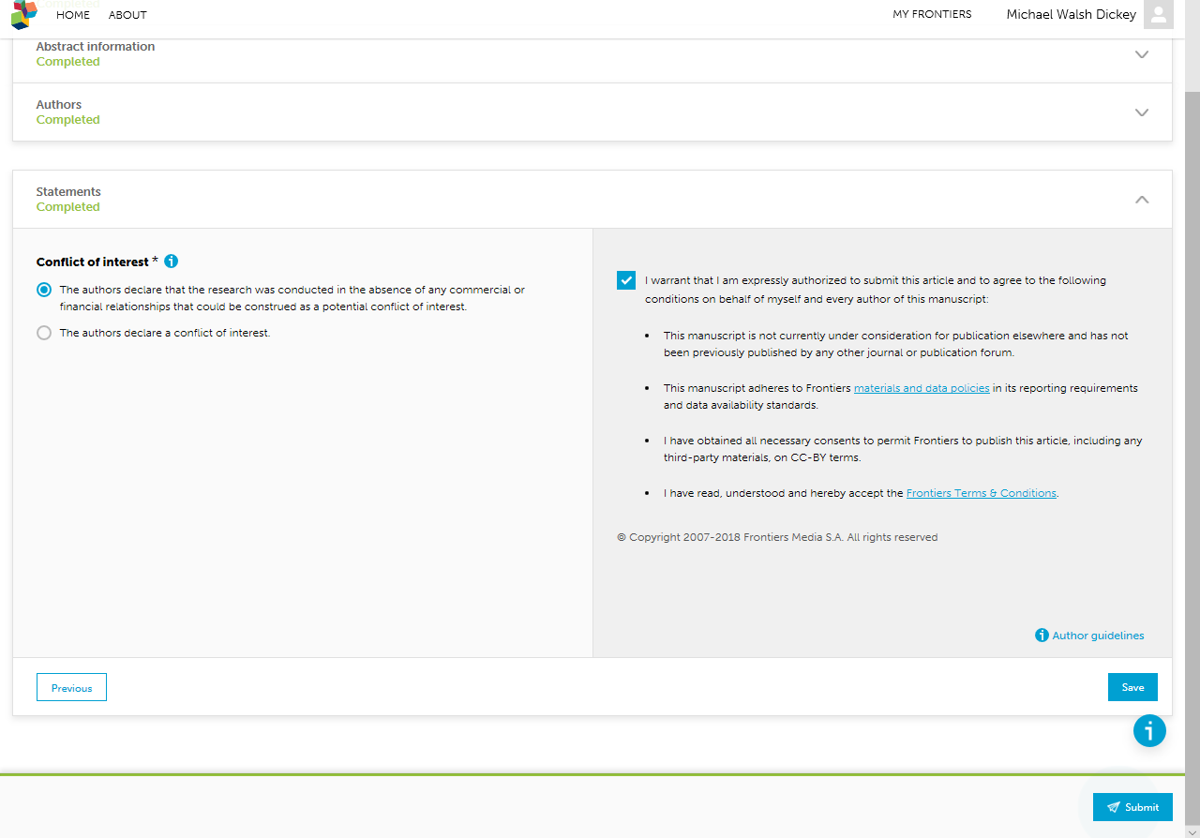

Complete COI information as needed, check the box, and SUBMIT.
Help with online submissions. If you have any problems using the online submission system, please contact the chair of the Program Committee (mdickey@pitt.edu) as soon as possible.
Deadlines. The text of all abstracts as well as any associated tables/figures must be uploaded to the website no later than 11:59 p.m. Pacific Standard Time on Wednesday, May 1, 2019. There will be absolutely no exceptions to this deadline.

Student Awards.
This award is given to the student presenting the most scientifically meritorious paper (either platform or poster presentation). Submissions are judged by the Program Committee on the basis of the abstract submission and the conference presentation itself. All full-time graduate students are eligible for the student award, although priority is typically given to students focusing on research. Student applicants must:
- be enrolled full time and be in good standing in a graduate program at the time of submission
- be the first author and presenter of the paper submitted
- not have received a student award from the Academy in the past

Students wishing to be considered must indicate this during the submission process (under “topic”).
Selection criteria for the meeting program. The Program Committee will review the abstracts anonymously. Selection of papers will be based on scientific merit, innovation, appropriateness for the Academy of Aphasia, on the representation of topics in the program.
Scoring Criteria: All conference abstracts will be reviewed for 1) Scientific Merit, 2) Conceptual and Scientific Innovation and 3) Appropriateness for the Academy of Aphasia. Consideration will also be given for the balance of topics represented in the program.
Rating | Descriptor | Guidance for Scoring
5 | Excellent | Excellent contribution (novel study, methodologically rigorous, clearly presented, highly relevant).
4 | Very good | Significant scientific merit, with few limitations or only minor flaws (e.g. in methodology, presentation, or originality).
3 | Good | Some scientific merit, but with limited impact (e.g. lack of originality; some methodological questions or flaws; data not collected); may not be clear what the relevance is to the field of aphasiology.
2 | Satisfactory | Some scientific merit, but significant flaws (e.g. in methodology and/or presentation of the results); study incomplete (i.e. proposed, but not yet carried out); minimal relevance to aphasiology
1 | Poor | Little or no scientific merit, or not enough basis to judge (e.g. study incomprehensible); not relevant to the field of aphasiology.

Notification regarding acceptance: You will be notified by email of the decision by the Program Committee by NO LATER THAN June 30, 2019.
Program availability. A PDF eBook with formatted abstracts will be distributed at the conference. Accepted abstracts will also be published online in Frontiers in Human Neurocience. Abstracts will be available in early fall for download from Frontiers.

Program Committee:
Michael Walsh Dickey (Chair)
Simon Fischer-Baum (Asst. Chair)
Erica Middleton
Bonnie Nozari
Dsork den Ouden
Brenda Rapp

